**CONFUSING WORDS**

1. **Further and Farther**

These two are very confusing. *Further* and *farther* both have the same meaning but are used in different situations. They’re pronounced in a similar way too, but with a difference – fur and far.

**Farther** — with far — is used when we’re talking about physical distance.

As a passenger in a car, you can ask the driver *“How much farther until we reach our destination?”*

In a race, you can say *“She ran farther and faster than him.”*

**Further** — with fur — is used for more abstract situations.

The human resources representative told me: *“If you have any further complaints, please tell me.”*

The professor told us: *“If you have any further questions you can ask me at the end.”*

In those examples, complaints and questions are not physical things, so you cannot use the word farther.

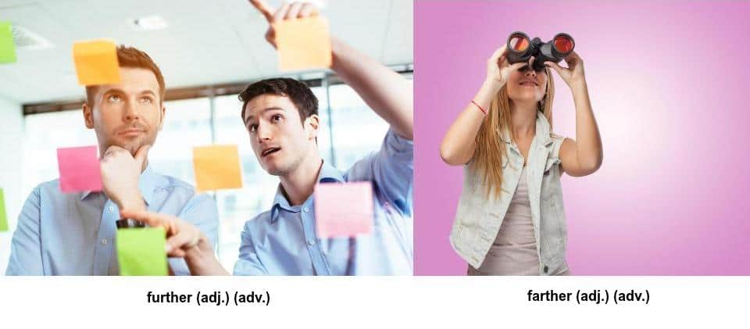

1. **Advice and Advise**

With these words we have similar spellings, similar meanings and only a slight difference in pronunciation.

**Advice** — with an “s” sound — is a noun. You can give your friend some advice.

*My father gave me one piece of advice – “Always be on time.”*

**Advise** — with a “z” sound — is a verb. With this word, you can advise your friend. The meaning of the two words is basically the same.

*She advised me to invest my money more carefully.*

1. **Hanged and Hung**

The difference between *hanged* and *hung* can be deadly.

**Hung** is the past of the verb **to hang**, most of the time.

*I hung my clothes on the clothes line.*

**Hanged** is the deadly exception, as it’s the past tense of **hang** in one very particular situation. Hang can also mean to execute a criminal by hanging them with a rope. In that case, the past tense of hang is hanged.

*The judge sentenced the murderer to be hanged.*

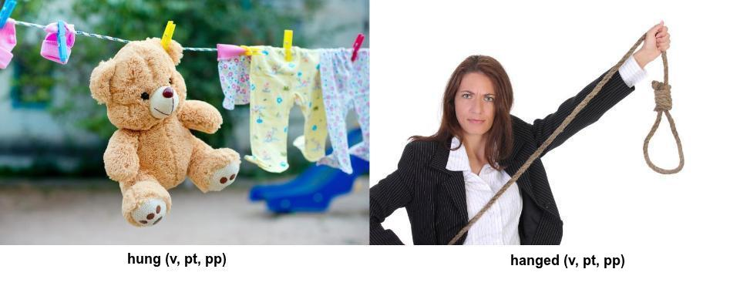

1. **Lose and Loose**

We spell them differently and we pronounce them differently, but English speakers still use these words incorrectly. Luckily, they’re easy to distinguish.

**Lose** – pronounced with a “z” sound – is a verb meaning to not have something anymore, to be unable to find something or to not win. You lose your cell phone, or you lose your way while driving somewhere.

*I don’t want my football team to lose the game.*

**Loose** – with an “s” sound – on the other hand, is an adjective that means free, unattached or not tight. It’s also a verb meaning to untie or let go of something.

*A loose sweater feels very comfortable.*

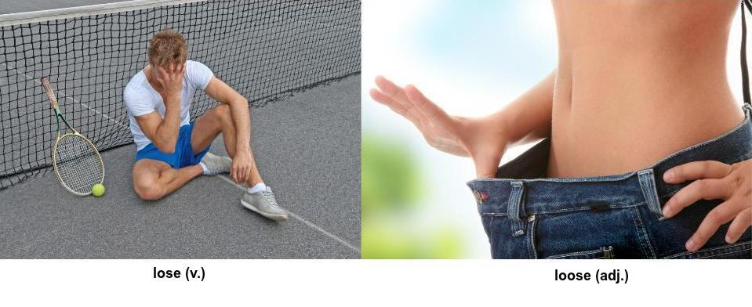

She will ……….. her money if she gambles with it.

The door handle fell off because it was too ……..

The criminal was ……. in the prison.

I …………. the painting on the wall.

If we drive any ………. tonight we’ll be too tired to continue driving tomorrow.

We should discuss this topic ……….. before we make a decision.

You can offer me ………., but that doesn’t mean I will follow it.

It’s essential that we find a professional to ……… us on this situation.